**Vanier College**

**Faculty of Science and Technology**

**System Development 420-436-VA**

Deliverable 02

**Grey Team**

Gennaro Finelli

Mohammed Hosein Ali

Alexandre Pham

Wayne De Leon

In collaboration with CyberStation

**(Code from our eCommerce class will be used for certain features of this project)**

**We, the Grey Team, certify that this assignment is our own work**

I, Gennaro Finelli, student ID# 2268107, certify that I have contributed to this deliverable, G.F

I, Mohammed Hosein Ali, student ID# 2055295, certify that I have contributed to this deliverable, M.H.A

I, Alexandre Pham, student ID# 2048017, certify that I have contributed to this deliverable, A.P

I, Wayne De Leon, student ID# 2179710, certify that I have contributed to this deliverable, W.D

Contents

# Executive Overview

Big

# Description of Business Domain

Big

# Description of Client

Big

# Business Problem

Big

# The Questionnaire

Big

# References

Big

# Bibliography

Big

# Description of Business Environment

## Meeting Schedule

Our team’s meeting schedule is as follows:

* Tuesday in Class: 13:00 – 16:00
* Thursday in Class: 12:00 – 16:00
* Discord meeting online: after class hours (Optional)

## Repositories

Our team is working on Github. We have chosen Github because it allows for multiple files to be shared and worked on at the same time with constant updates and details about those updates. The github repository is linked below.

* Github: <https://github.com/apalex/sys-dev-project>
* Below are our names next to our Github usernames:
  + Gennaro Finelli: gennarofinelli
  + Mohammed H. Ali: iS1ngforU
  + Alexandre Pham: apalex
  + Wayne De Leon: 2179710

## Communication

Our team will be communicating exclusively via discord. Discord is a very convenient communications platform where we will be able to share files and exchange messages. The team members of this assignment all agree it is the most comfortable platform for us to use. The policies we have set up are:

* Follow the schedule
* Respect other team members:
* Do not speak over someone else
* Remain open minded
* Don’t be rude

## 

## Synchronous Meetings

Our synchronous meetings that include all team members are written in the Meeting Schedule part in this document. Our synchronous meetings will be mostly in class during Tuesdays and Thursdays. The reason for this is we would have better communication in person, and it fits our schedule for the week. Also, it would be very helpful to work on our project in class so we could ask our professors some questions if we encounter problems. If our work is not done and our time is not enough, we have an option to meet online through discord.

We will be having synchronous meetings with the Client and the schedule will depend on the Client’s schedule. Our main point of contact with the Client is *Mohammed,* as his job is in the Client’s gaming lounge. Then Mohammed will communicate with the team to voice out the Client’s needs.

## Areas of Responsibility

Most of our work on the project is divided equally. Some responsibilities may change as we work further.

* Mohammed will be the team’s main contact person between our client and our team. The reason being is because he works for the client in her gaming lounge, so he knows and meets the client more than the group.

The work that is in rotation will be mostly on the team leader.

* The responsibility is that the team leader will work on the team logbook so that each member of the team experiences team organization and keep each member aware of the project’s progression.

## Contact Information

* Alexandre Pham: [alexpham2003@gmail.com](mailto:alexpham2003@gmail.com) | 5147093551
* Gennaro Finelli: [gennarofinelli05@gmail.com](mailto:gennarofinelli05@gmail.com) | 5146492232
* Wayne De Leon: [wayned0527@gmail.com](mailto:wayned0527@gmail.com) | 4384060527
* Mohammed H. Ali: [m.hali2002@hotmail.com](mailto:m.hali2002@hotmail.com) | 2055295

## Client Contact

There will only be one contact with the client: our main contact for the client will be Mohammed, due to him being the one to have found our client and he already has a professional relationship since she is his boss. The main source of contact with our client will be done through SMS.

* Phone: 5146384311
* Email: [sara.chahrour@hotmail.com](mailto:sara.chahrour@hotmail.com)

## Reports

In our group, the team agreed that the best way to finish each deliverable goes:

* We will have a short meeting to talk about the work and divide tasks.
* The team leader would look into the tasks done if each member did their tasks.
* The team leader would make the members sign the documents for deliverables.
* Wayne De Leon will review each deliverable for missing content and design flaws.
* The team leader will do one final review of the deliverable before all members can submit.

# Project Plan

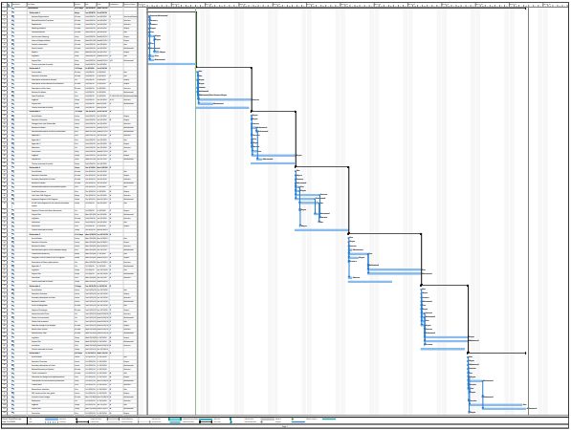

[Click here to view the PDF file](../../Documents/ProjectPlan.pdf)